FACULTY EVALUATION
Programme Name: Social Entrepreneurship Program (SEP)- START Alumni MASTERCLASS (16th February 2026 - 20th February 2026)
Session: Review current funding of social enterprise / Identify Funding Gap/ Preparing funding plan
Faculty Name: Dr. Tom Buringuriza
No. of Respondents: 7
No. of Participants: 10
Evaluation Parameter | (%) Individual Score | (%) Programme Average
Punctuality (Commencement and Completion of Sessions) | 83 | 80
How well do you understand the core concepts presented? | 71 | 80
Rate your confidence in applying the new skills learnt | 69 | 74
Degree of Faculty preparedness for the sessions | 91 | 92
Content and methodology of the program | 83 | 87
Quality of class and group discussions | 71 | 74
The information presented in the course is relevant to my work (ministry) | 84 | 88
Average scores | 79 | 82

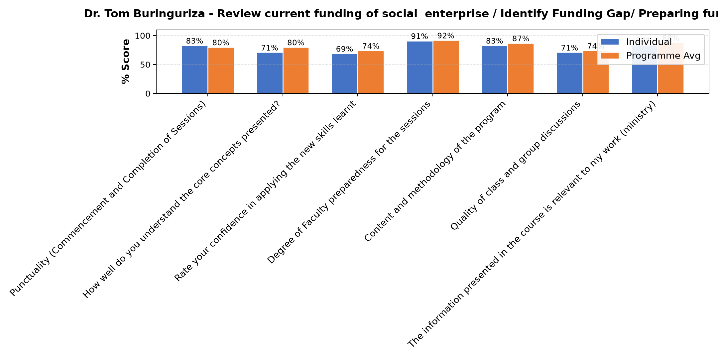

Comments & Feedback
- • Identifying a finding gap remains a challenge.
- • Lack of some skills
- • Distance from the project site
- • Lack of proper planning and resources.
- • Lack of resources
SUBMITTED THROUGH:
SBS Evaluation Automation System

